Contents
STRING METHODS: 2
LIST METHODS: 2
DICTIONARY METHODS: 3
SET METHODS 3
SET METHOD 4
FINAL COMPARISON 4
BUILT-IN FUNCTIONS IN PYTHON 4

Python notes:

STRING METHODS:
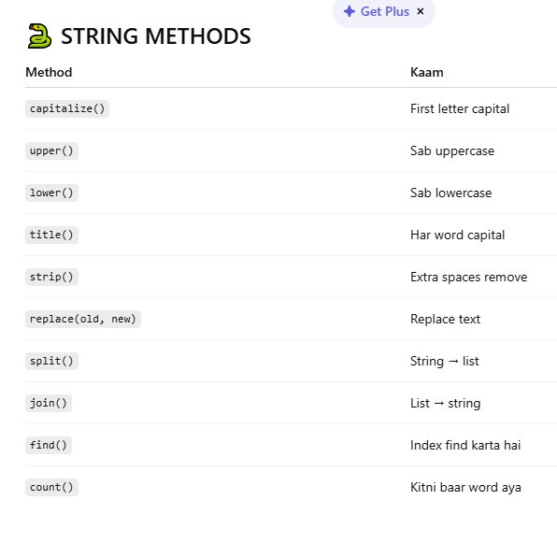

LIST METHODS:
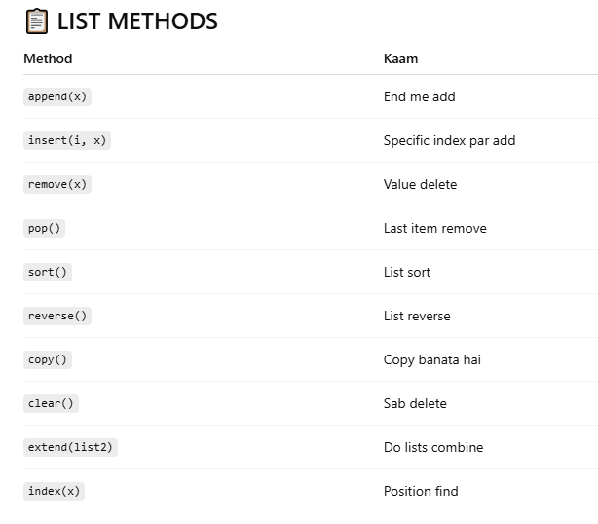

DICTIONARY METHODS:
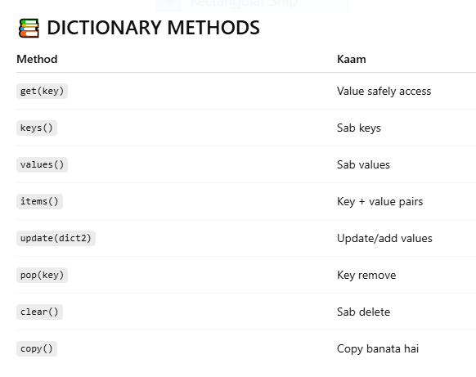

SET METHODS
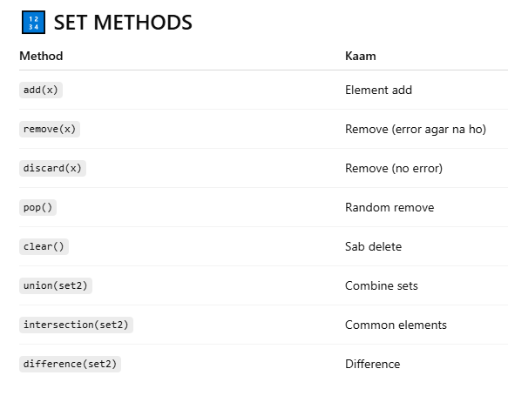

SET METHOD
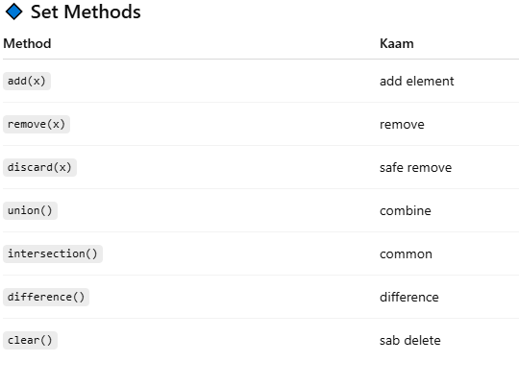

FINAL COMPARISON
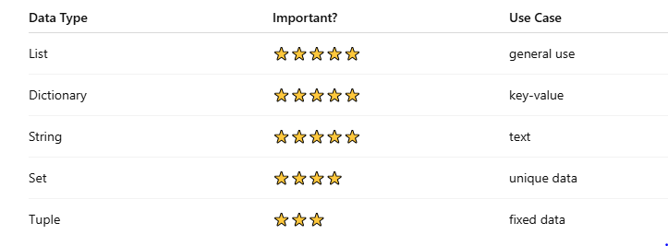
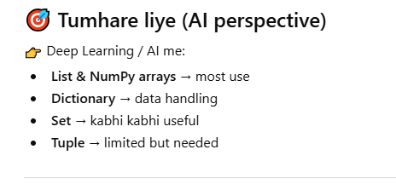

BUILT-IN FUNCTIONS IN PYTHON

1.Basic Functions:
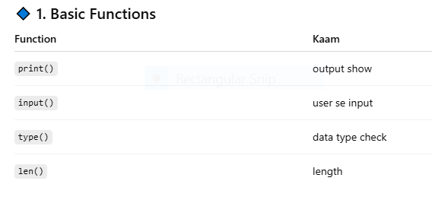

2.Number Functions:
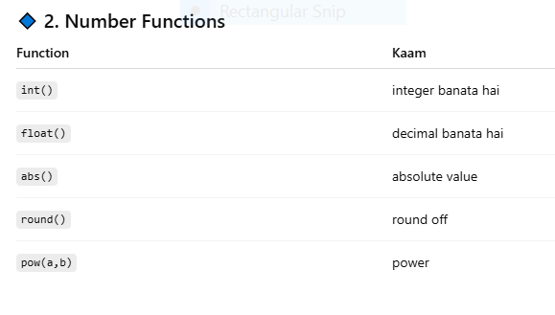

3. List / Iterable Functions:
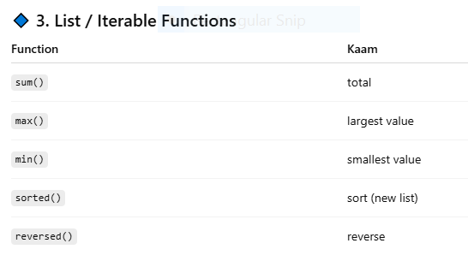

4. Loop Related:
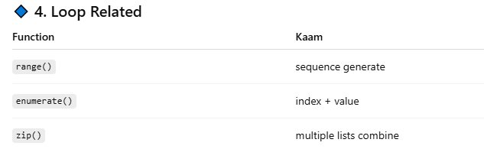

5. Boolean Functions:
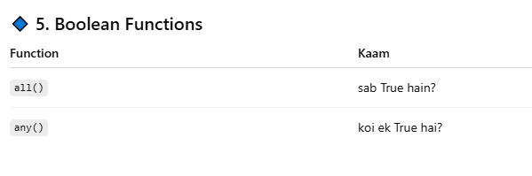

6. Conversion Functions:
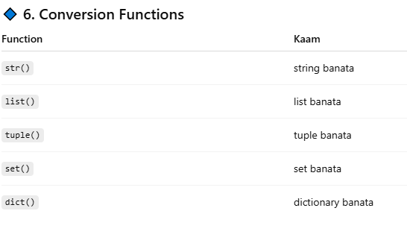

7. Help & Debugging (VERY IMPORTANT 🔥):
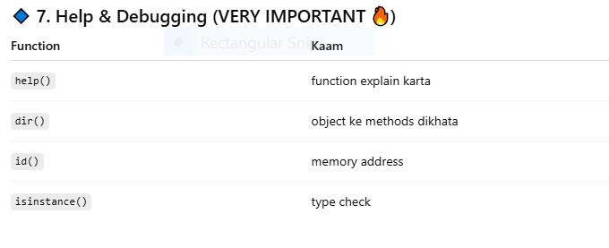

AI / Deep Learning me use:
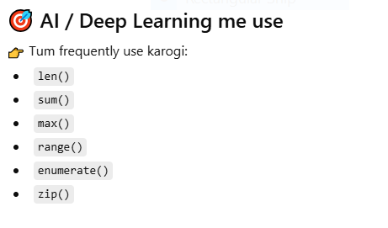

Golden Tip:
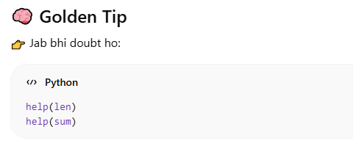

1. Loops: Definition
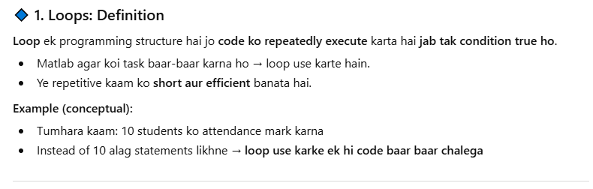

2. Types of Loops in Python:

2.1 for loop:

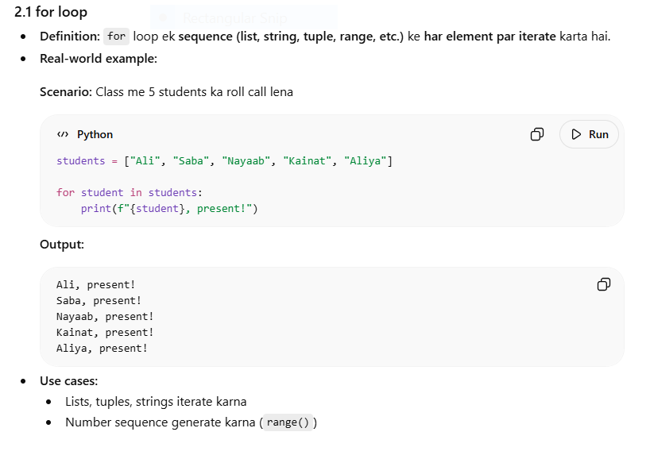

2.2 while loop:
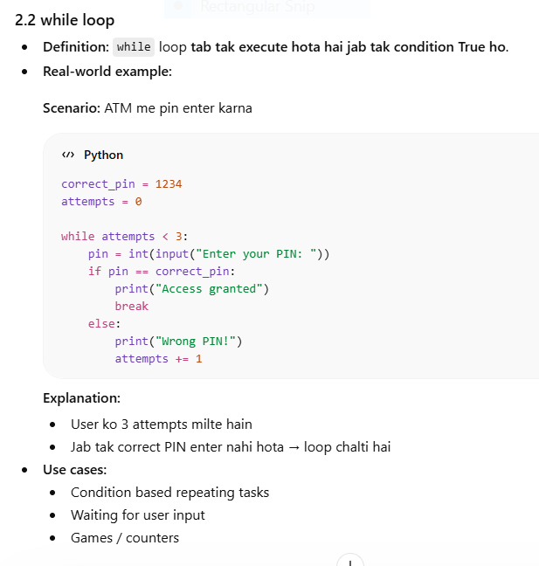

2.3 Nested loops:
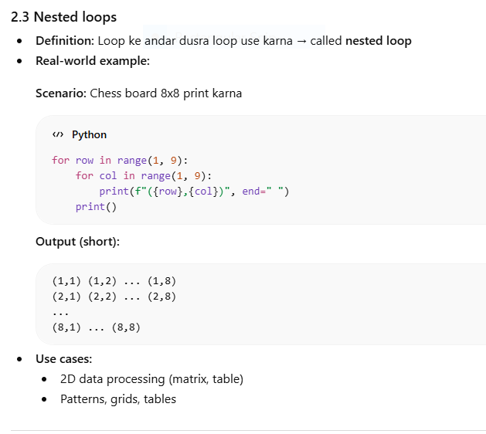

2.4 Loop control statements:
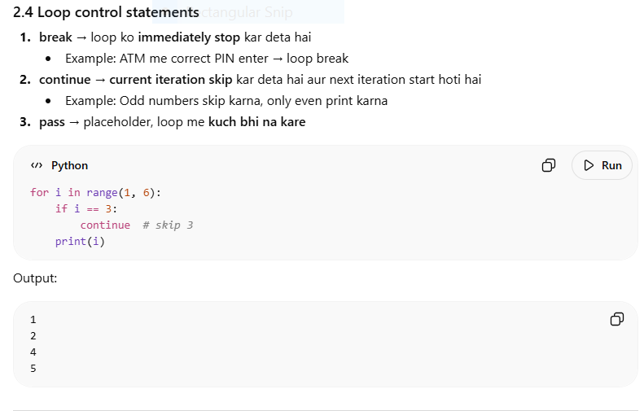
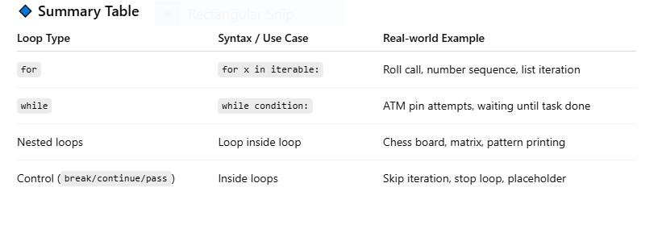

Functions:
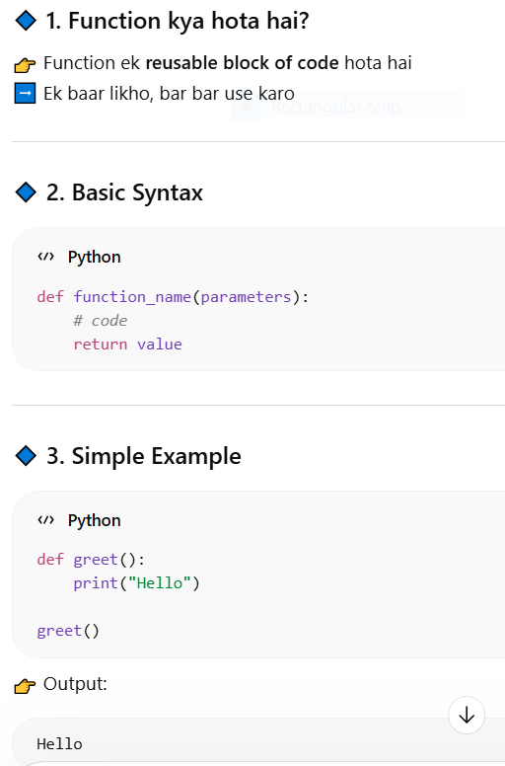

Function with parameters:
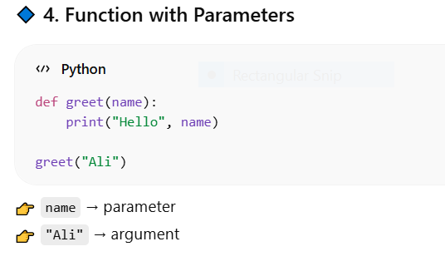

Function with arguments:
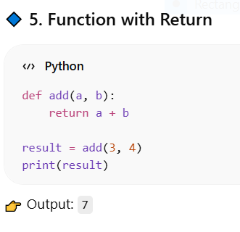

Default Parameters:
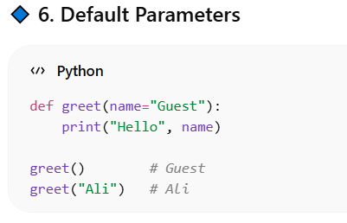

Multiple Return Values:
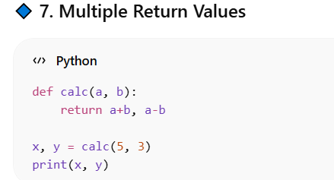

Important Terms:
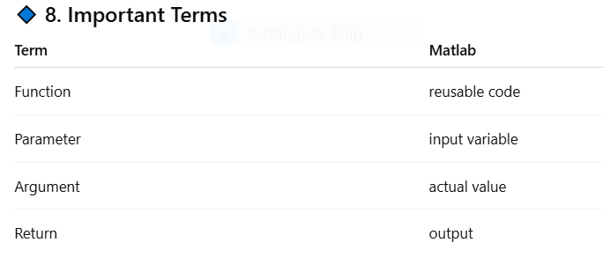

AI me use kahan hoga:
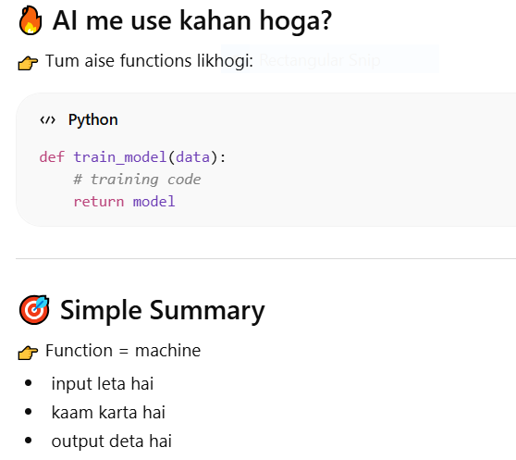

CONDITIONS IN PYTHON:

Basic if

If else
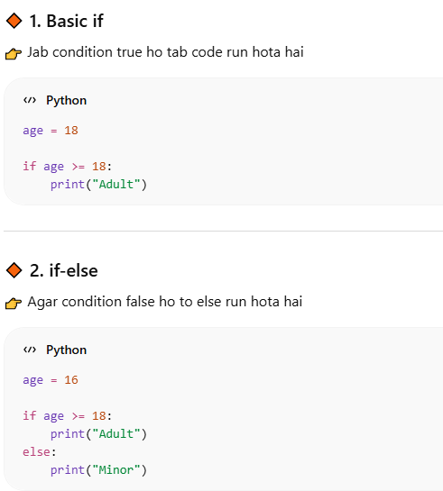
else-if-else:
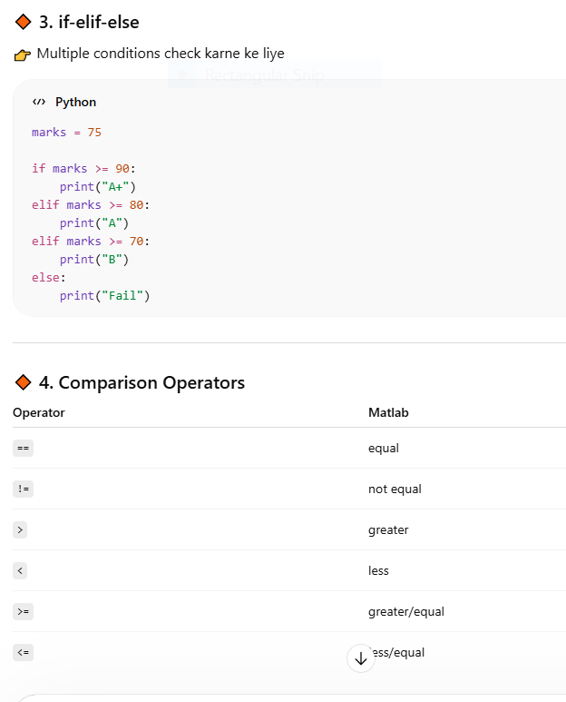

Logical Operators:
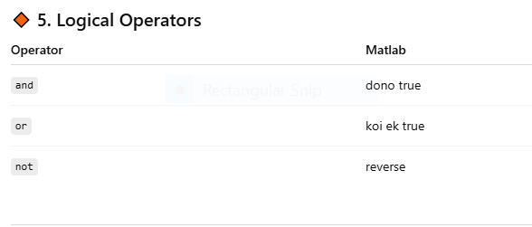

Nested if:
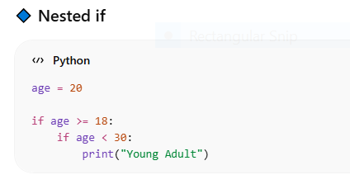

AI me use:
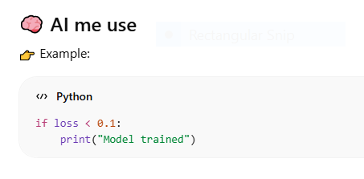

Python me switch-case ka alternative:
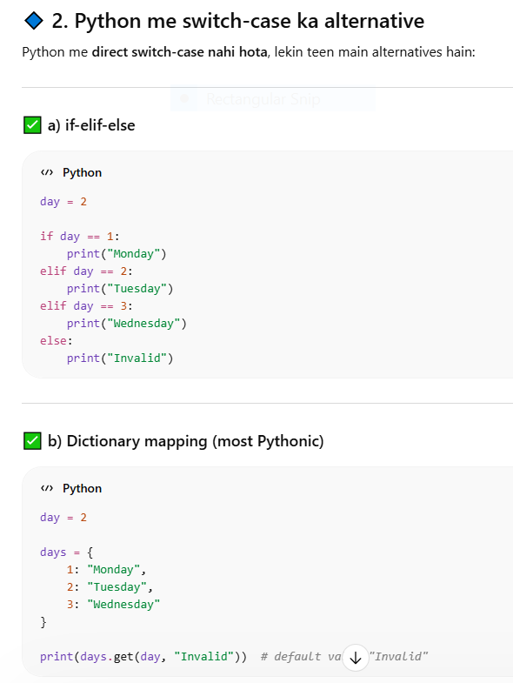

Match case:
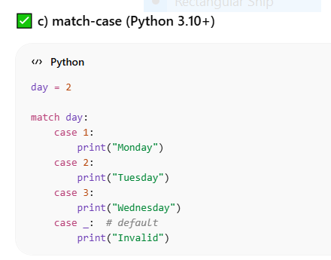

FILE HANDLING IN PYTHON:
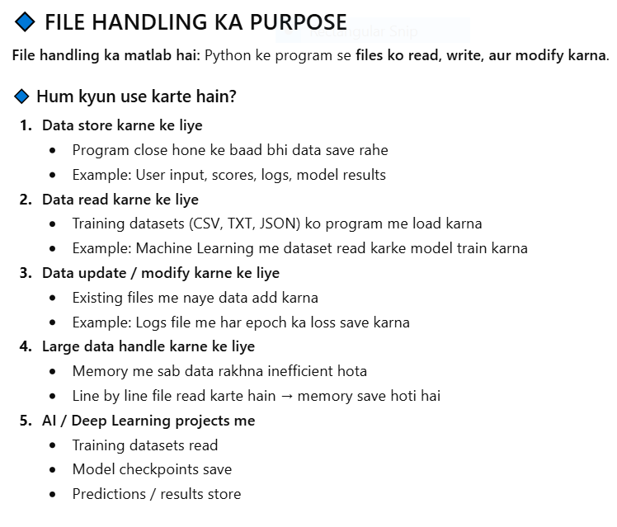
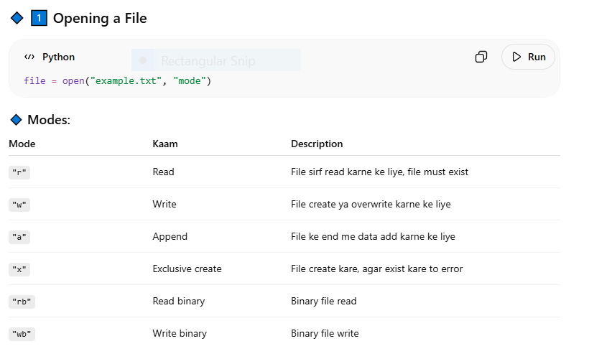

Reading a File:
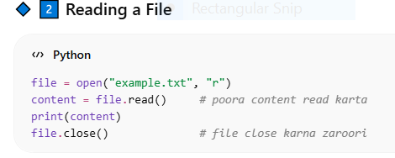
Other Read Methods:
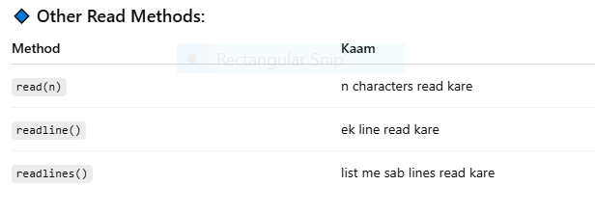

Using with (Recommended):
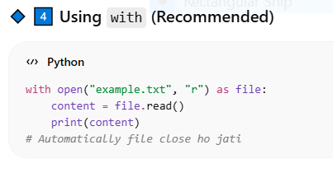

File Pointer
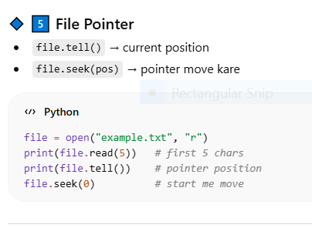

Working with Binary Files:
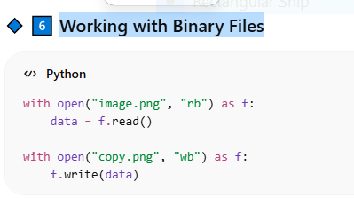

Deleting a File:
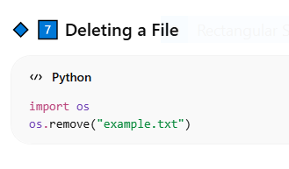

Checking if File Exists:
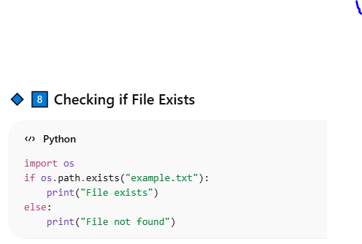

Reading Large Files:
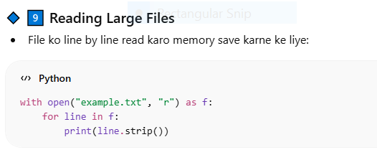

Common Errors:
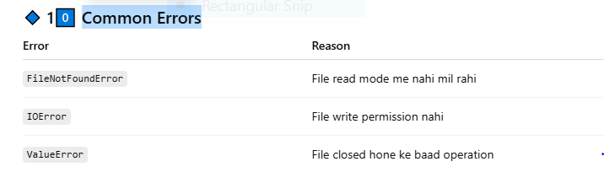

Real-life AI / Deep Learning Usage:
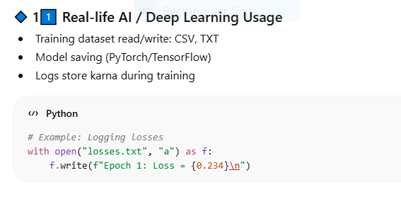
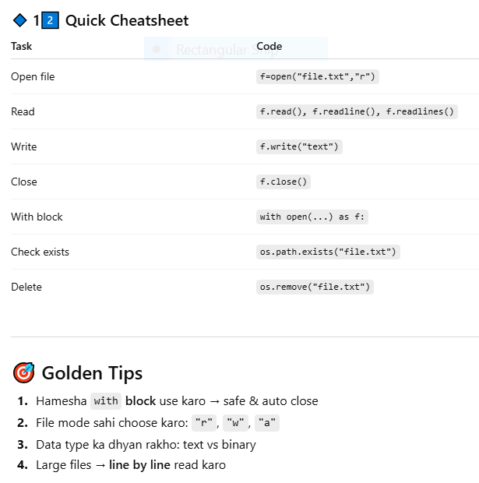

STATIC METHOD IN PYTHON:

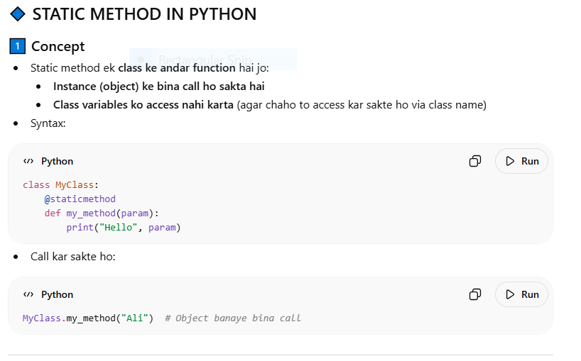
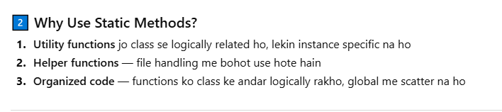

Tumhare example ka breakdown:
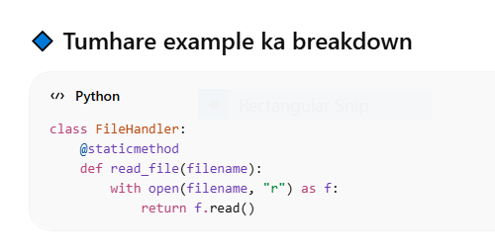

Agar static na use karo:
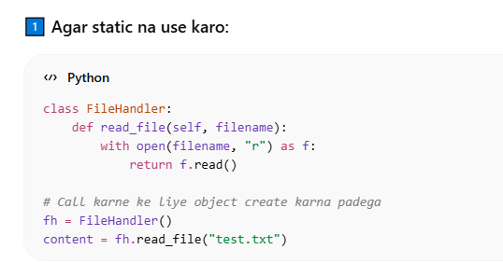

Agar static use karo:
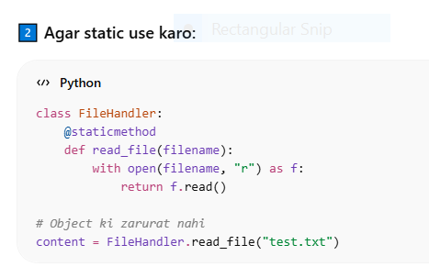
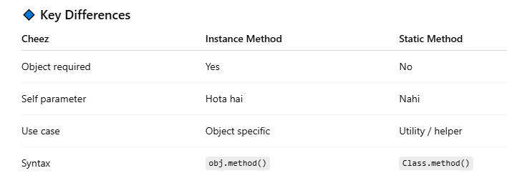
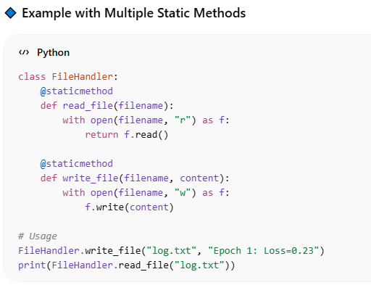

OOP kya hota hai:
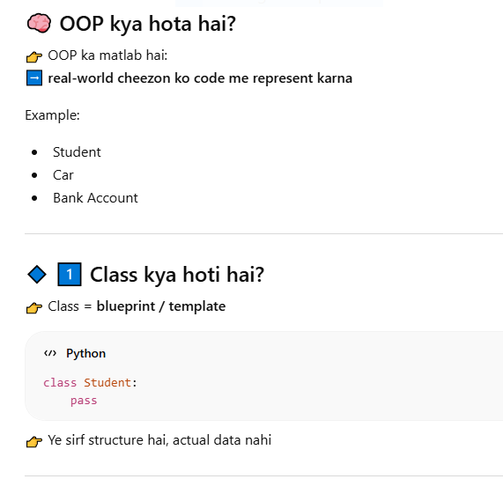

Object kya hota hai?
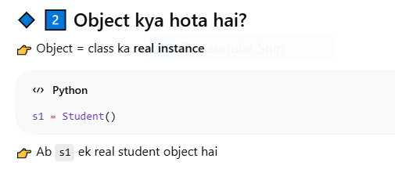

Attributes (Variables)

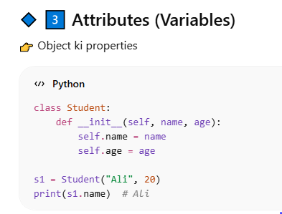

Methods (Functions inside class):
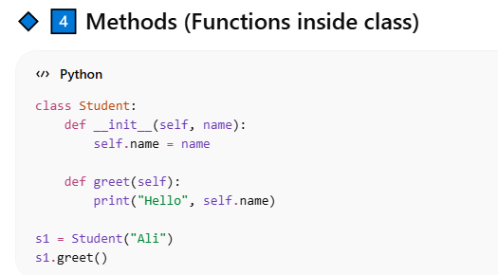

__init__ kya hota hai?
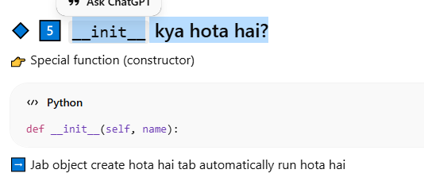

self kya hota hai?
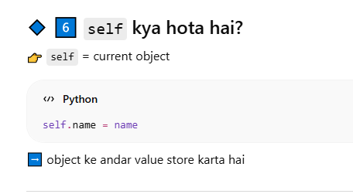

Simple Real Example:
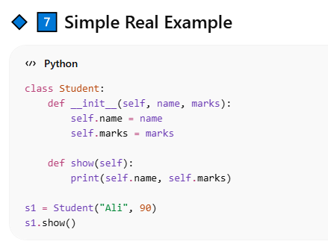

OOP ke 4 pillars (important 🔥):
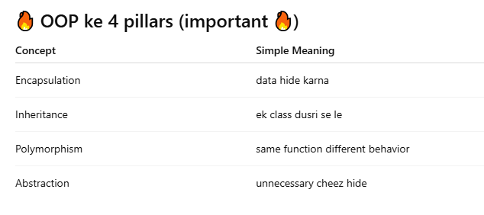

Encapsulation:
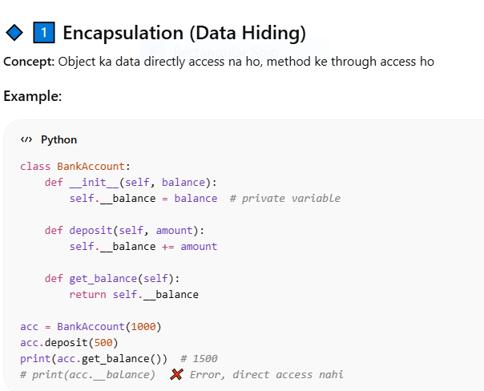

Inheritance (Ek class dusri se le)
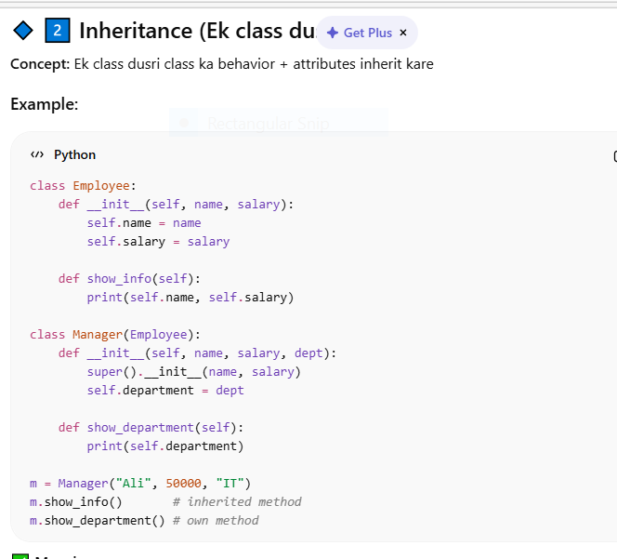

Polymorphism (Same function, different behavior)
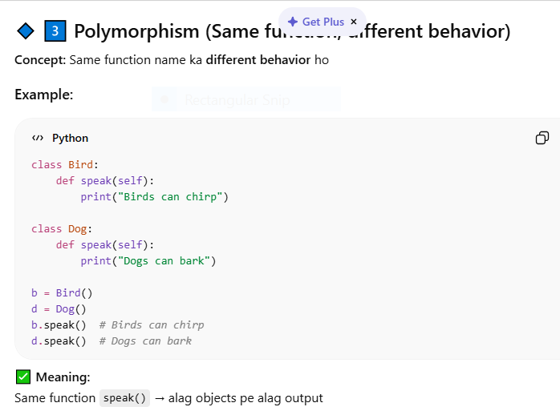

Abstraction (Unnecessary cheez hide)
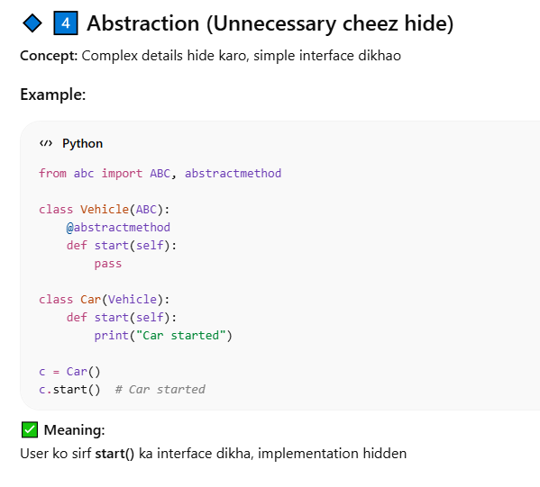

Golden tips
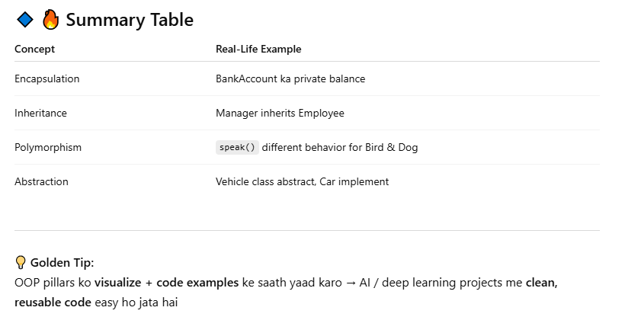
class Cat:
def __init__(self, call, eat):
self.call = call
self.eat = eat

def working(self):
print(f"Cat says {self.call} and eats {self.eat}")

class Dog(Cat):
def __init__(self, call, eat, night):
super().__init__(call, eat)
self.night = night

def working(self):
print(f"Dog says {self.call}, eats {self.eat} and does {self.night} at night")

# Objects
animal1 = Cat("meow", "meat")
animal2 = Dog("barking", "pulao", "guarding")

# Method calls
animal1.working()
animal2.working()

Error handling:
